

INSTRUCTIONS FOR INTERNAL ASSIGNMENT – PROGRAMMING IN C - Practical -DCA1130_NOV_2021


INSTRUCTIONS FOR INTERNAL ASSIGNMENT

Programming in C- Practical (DCA1130_Nov_2021)

Duration: 3 Hours Maximum Marks: 70

This is to inform you that your Internal Assignment of Programming in C (DCA1130) has been published in LMS. You have to login in Virtual Programming environment and complete Programming in C Practical.

Note:

- There are 7 projects/programs each of equal weightage and compulsory to attempt.
- The last date for successful completion will be 15- March-2022.

Steps to attempt the Internal Assignment are as follows:
- Log in to LMS using your credentials.
- Select the “Programming in C-Practical” option from the Courses.
- Choose “Virtual Programming Lab”.
- Click on the “Programming Lab for C Practical for BCA” button.
- Click on the “Start” button and select the “Start Coding” option, it will redirect to project instructions, read it thoroughly before closing.
- Click on the “Next Project” option, it will redirect to the first assignment (Project) i.e., Program1.
- Read the question and start working on the first project/Program1 by writing your C Program. Then Save, Compile, and give console input to Run the program.
- Click on the “Submit Project” button. Then click on the Next Project Option, it will redirect you to the second assignment question.
- Repeat step 5 onwards for all other projects/programs.
- Finally, click on the "Submit Exercise” button after completion of the last project/program.

Please refer to the screenshots provided in this manual for more clarifications.

HAPPY LEARNING!

Step-1: Log in to LMS using your credentials.

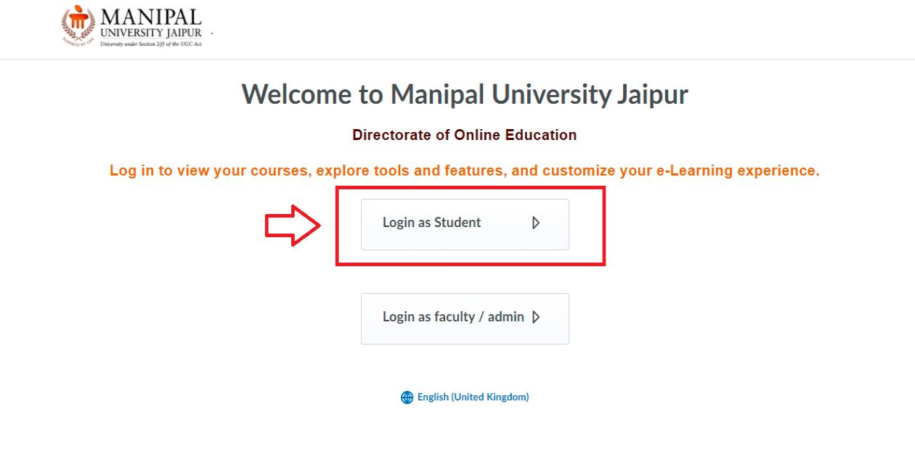

Step2: Select the “Programming in C-Practical” option from the Courses.
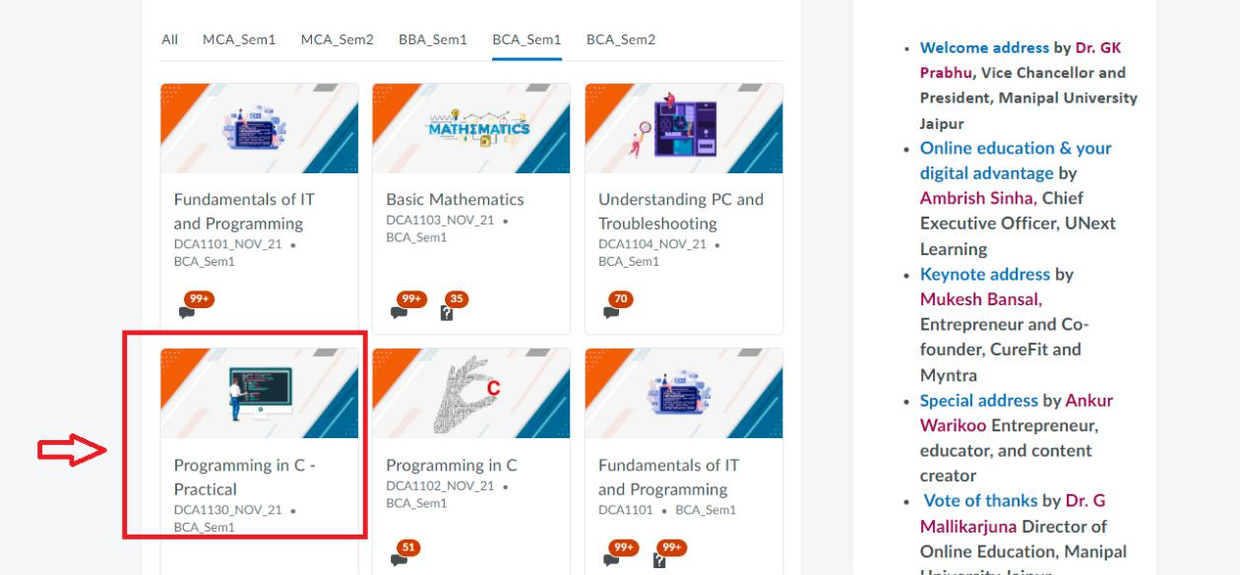
Step3: Choose “Virtual Programming Lab”.

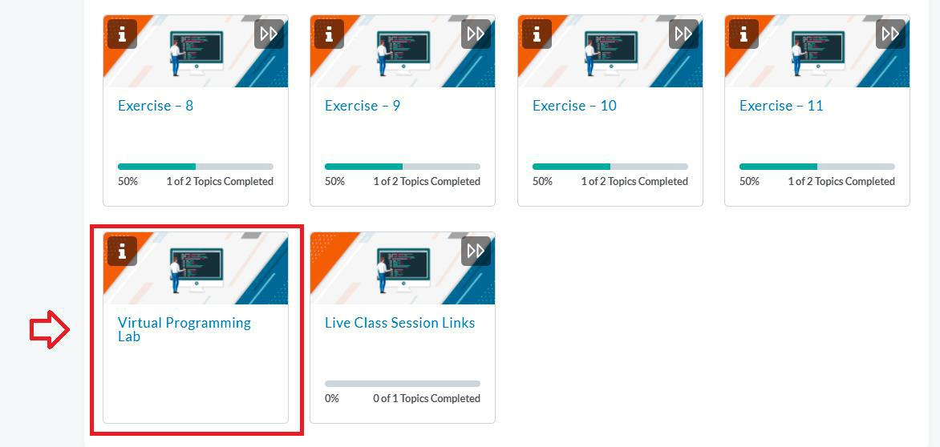

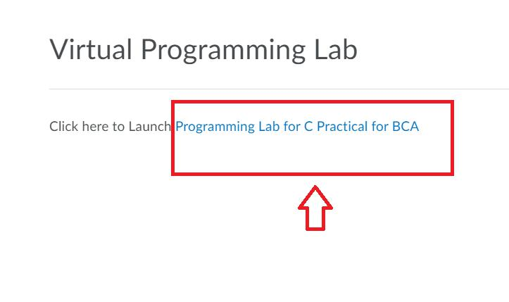
Step 4: Click on the “Programming Lab for C Practical for BCA” button .

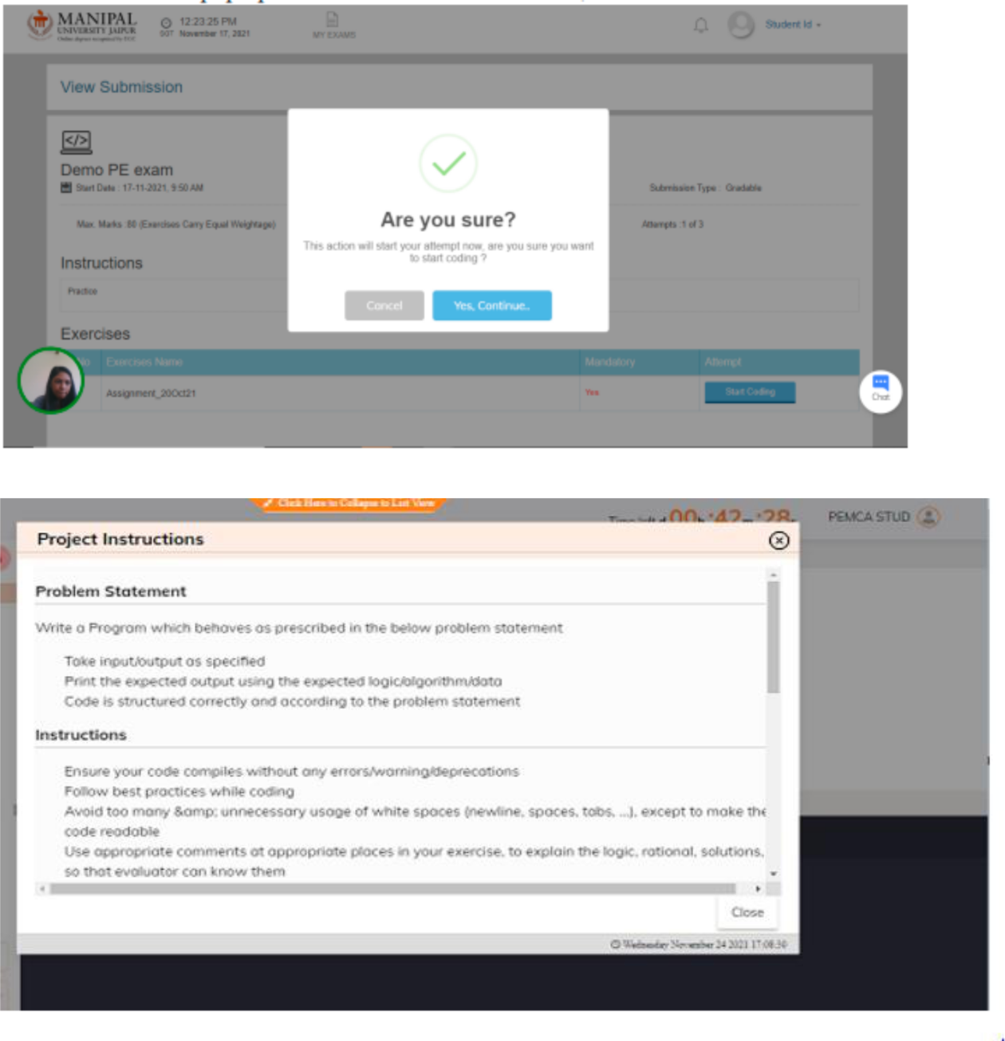
Step 5: Click on the “Start” button and select the “Start Coding” option, it will redirect to project instructions, read it thoroughly before closing.
Step 6: Click on the “Next Project” option, it will redirect to the first assignment (Project) i.e., Program1.
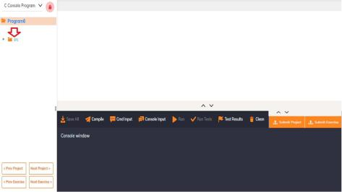

Step 7: Read the question and start working on the first project/Program1 by writing your C Program. Then Save, Compile, and give console input to Run the program.
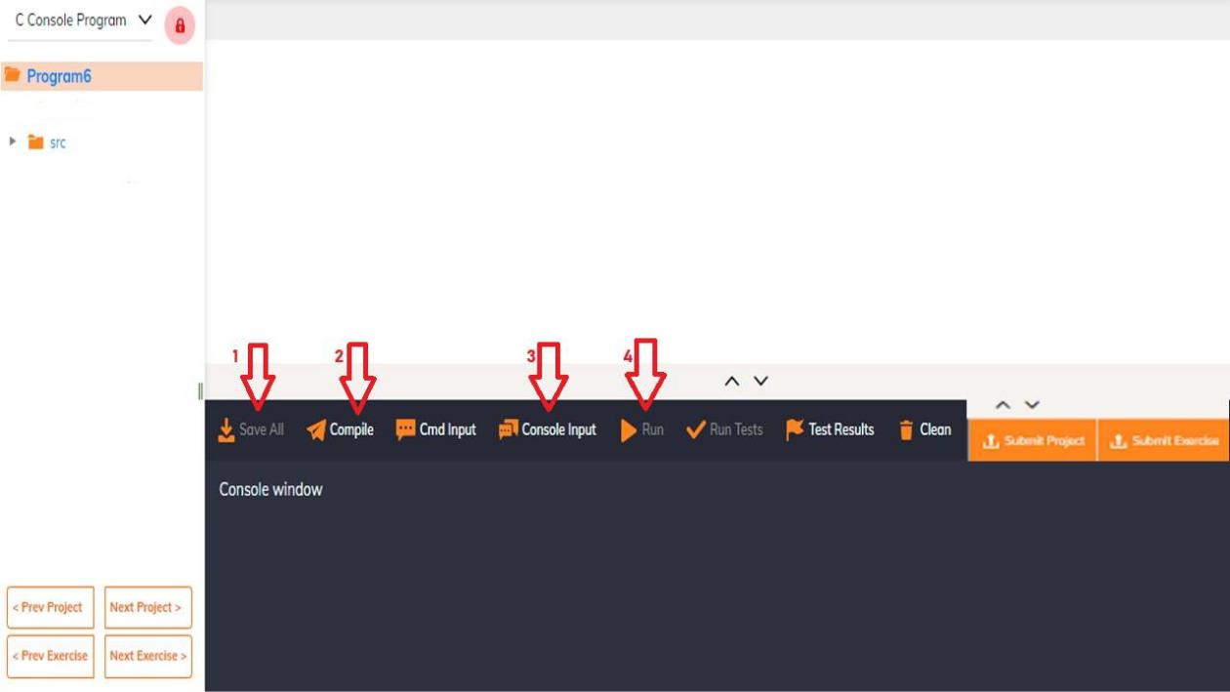
Step 8: Click on the “Submit Project” button. Then click on the Next Project Option, it will redirect you to the second assignment question.
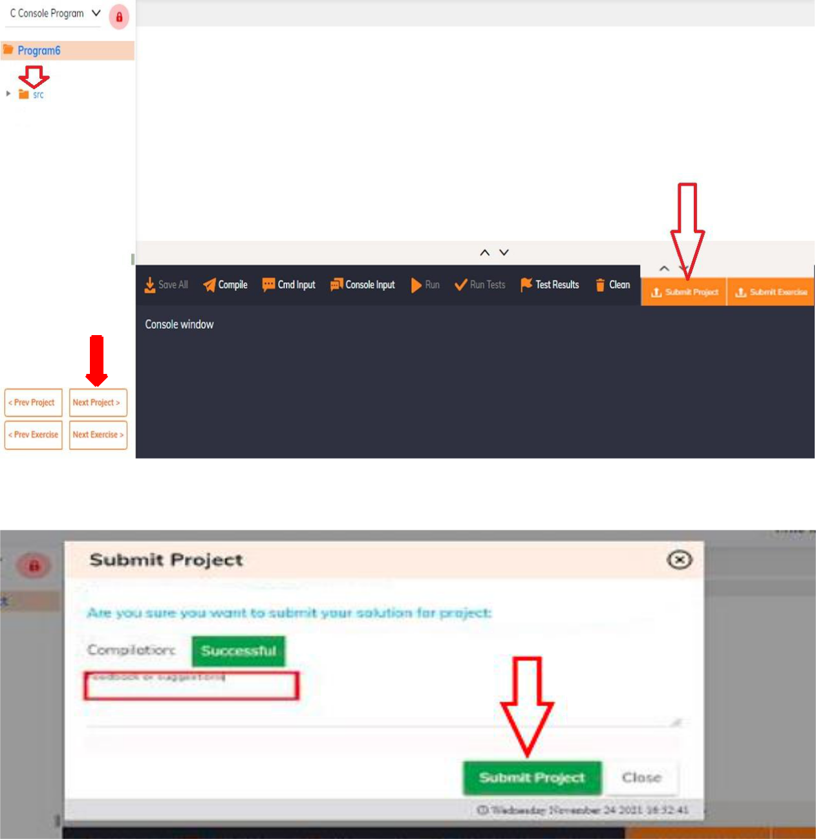
Step 9: Repeat step 5 onwards for all other projects/programs.
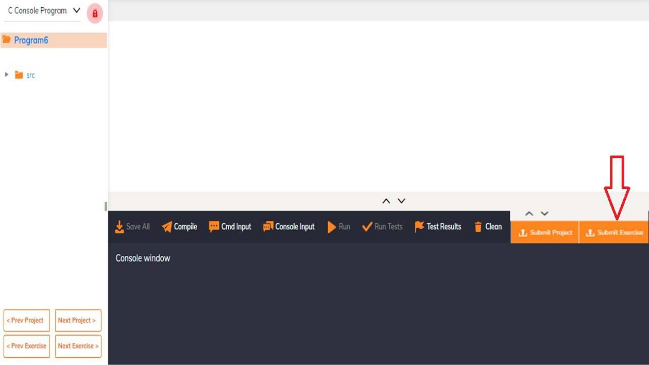
Step 10: Finally, click on the "Submit Exercise” button after completion of the last project/program.

Note: All 7 Programs to be completed. Each carry 10 marks (Maximum 70 marks) for Internal Assignment for Programming in C– Practical course.

